Sequence
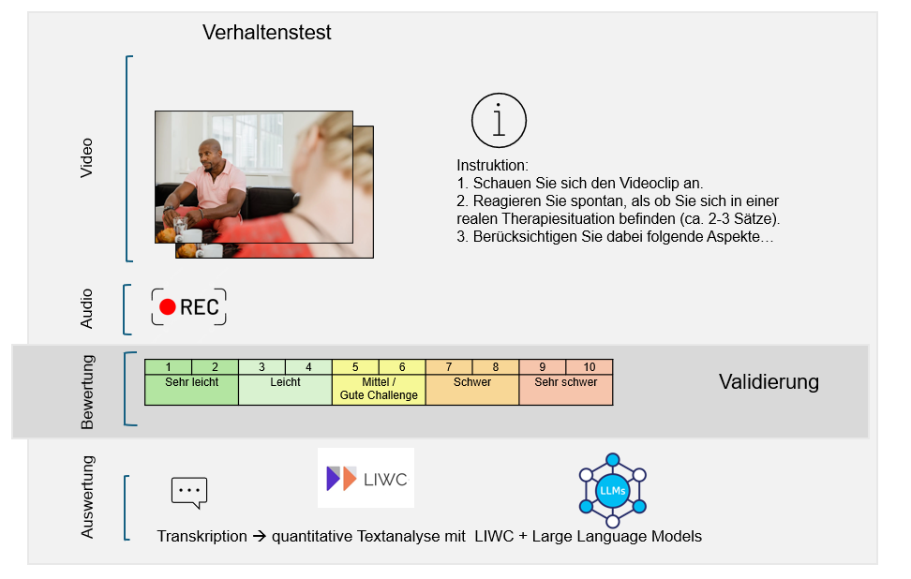

Overview of the competence dimensions and skills criteria

Transcultural competence as an ability...
...to recognize that there are relevant topics (the " whether "; content exploration – how well relevant aspects of the patient, e.g., cultural background, family system or social contexts, are recognized and addressed in the conversation):
- Inquire about subjective ideas about illness and healing
- Include family and social systems
- Consider cultural and contextual factors (e.g., migration history).
...to approach these topics with the right attitude (the " how "; attitude/interaction – how non-judgmental, empathetic and open the therapist reacts , without judging or giving advice):
- Proactive handling of not knowing: the willingness to ask questions instead of making assumptions.
- Ambiguity tolerance: the ability to endure contradictory viewpoints and uncertainties without judging or guessing.

dimension | Skill criteria | instruction
Inquire about subjective ideas about illness and healing | - Validates the statement of the patients .  - patients ' subjective ideas about illness or healing and invites further reflection.  - Shows that he/she is flexible. | "Explore the patients ' subjective ideas about illness or healing ."
Proactively dealing with not knowing | - Has a collaborative and interested attitude.  - Proactively deals with lack of knowledge, i.e., asks patients questions to better understand their statements.  - Encourage patients to explain their statement in more detail. | "Encourage patients to explain their statement in more detail."
Consideration of cultural factors | - Suggests whether cultural or contextual factors (e.g., migration history) could influence the patients ' complaints.  - The emphasis here is clearly on the word "suggest".  - Avoid responding with a leading question. | "Find a way to reflect together with the patients on whether cultural or contextual aspects are influencing their symptoms."
Inclusion of the family system | - Has an empathetic and validating basic attitude.  - Explore the patients ' complaints by involving the family system.  - Avoid responding with advice. | "Explore the patients' complaints within the context of their personal environment."
Ambiguity tolerance | - Validates that the topic is of great importance to the patients .  - Explore the perspective expressed by the patients and invite them to further reflection on the idea.  - It does not judge viewpoints as right or wrong. | "Explore the perspective expressed by the patients and invite them to further reflection."

Final scripts for the dimensions

1: Subjective conceptions of illness and healing
No. | Background of the person | Difficult situation (Prompt) | Example of a suitable answer: "appropriate" | Example wording for the answer: "unmeasured"
02 | A 27-year-old patient from Syria has been living in Germany for four years. He suffers from post-traumatic stress disorder and depression. | I often wonder if the mental health problems I've had since coming to Germany are some kind of punishment from God for my past behavior. My parents paid so much money for my escape. I simply abandoned them. And this is the just punishment for it. | It's understandable that you feel guilty if you believe your problems are a punishment from God. Do you believe that leaving your parents behind is the reason for your problems? | That's just superstition. There's no point in dwelling on such thoughts – focus on the present instead. Feelings of guilt won't get you anywhere.
04 | A 47-year-old man, born in Turkey and raised in Germany, presents with chronic physical complaints (tinnitus and back pain). | About five years ago, I broke off contact with my family in Turkey. After a short time, my health deteriorated rapidly. Since then, I've struggled with recurring health problems, I argue more with my wife, and things aren't going well at work either. That's no coincidence. | It sounds as if the severing of contact with your family in Turkey is causing you increasing problems that are very distressing for you. What are the causes of your problems? | That definitely has nothing to do with the lack of contact. You're seeing a connection where there might not be one. Physical ailments don't simply arise just because you have no contact with your family.
05 | A 54-year-old Turkish patient has been working in Germany for 26 years. For the past two years, he has suffered from agoraphobia with panic disorder. He is currently on sick leave as a result. | I already told you I'm sick. Why should I describe it in more detail now? You're the expert. It's your job to find out exactly what's wrong with me. You should know that. | I understand that it's difficult for you to talk about your symptoms. Questions are an important part of therapy because they help me understand your perspective and your explanations for your symptoms. What do you think are the causes of your symptoms? | I can't help you if you're not willing to share information with me. It's not my job to guess your symptoms – if you don't understand that, the therapy won't work.

2: Proactively dealing with not knowing
No. | Background of the person | Difficult situation (Prompt) | Example of a suitable answer: "appropriate" | Example wording for the answer: "unmeasured"
10 | A 51-year-old Lebanese patient is being treated for agoraphobia and a depressive disorder. She has lived in Germany for 20 years. | I absolutely cannot discuss my mental health problems with my family. It's simply something a woman in my culture isn't allowed to do. They wouldn't understand. It would be a complete no-go! My husband would feel betrayed by me. He wouldn't understand. | It sounds like you're in a very difficult situation where you feel your problems can't be discussed within your family. What exactly do you mean by saying that this would be an absolute "no-go" in your family? | If you never speak openly, no one can help you. At some point, you have to make a decision.
12 | A 27-year-old patient from Syria has been living in Germany for four years. He suffers from post-traumatic stress disorder and depression. | [Nervous] I don't know if this will work for me. I'm not sure if I understand everything correctly or if I can find the right words. Maybe I should stop the therapy and invest more time in learning German. | I think it's good that you're expressing your doubts openly. It sounds like you're putting yourself under a lot of pressure when it comes to language. Unfortunately, I don't know what the best course of action is for you right now. Perhaps we can discuss together what might be best for you at the moment. | Then it might really make more sense to just learn German first. You need good language skills for therapy.

3: Consideration of cultural factors
No. | Background of the person | Difficult situation (Prompt) | Example of a suitable answer: "appropriate" | Example wording for the answer: "unmeasured"
17 | A 31-year-old patient immigrated to Germany from Poland with her parents when she was seven years old. She feels exhausted and reports heart palpitations and severe back pain. She has also been drinking more alcohol for the past three years and has become withdrawn. | I've been thinking a lot lately about how to deal with my bisexuality. If I tell my family the truth, they'll consider me dishonorable. My German friends just don't understand why I haven't come out yet and can't just be myself. They can't understand why it's so hard for me to be open about my sexuality, especially with my family. I feel like I can't fully open up to either my family or my friends and always have to hide a part of myself. | You seem to be in a very difficult situation, torn between your family and your friends. I wonder if this feeling of not being able to fully open up is also related to the different cultural expectations of your family and your friends? | That's really not a problem anymore these days. If you've already come out to your friends, then you should just be consistent. You're an adult, and what your family thinks shouldn't bother you so much – at some point, you have to live your own life .
18 | A 54-year-old Turkish patient has been working in Germany for 26 years. For the past two years, he has suffered from agoraphobia with panic disorder. He is currently on sick leave due to this condition. The underlying cause is family conflicts. | I used to dream of having a management position. But for that, I need a degree, but studying – that's not for me. Look, guys like me with a migration background…we don't belong at university. That might sound racist, right? But that's just the reality… | First of all, I'm sorry to hear that you've experienced this. The idea that you shouldn't study and pursue a leadership position could therefore be related to your experiences of racism . I wonder if these experiences have weakened your self-confidence. | If you're already putting yourself down like that, then you'll never reach a leadership position. These days, everyone has the opportunity to study. Perhaps you simply lack discipline or motivation. In any case, constantly bringing up your background won't get you anywhere.
19 | A 27-year-old patient from Syria has been living in Germany for four years. He suffers from post-traumatic stress disorder and depression. | [ Ashamed ] I'm afraid that people won't understand me or will laugh at me. I feel like I don't really belong because I don't speak the language perfectly. I constantly make mistakes in the language, even after all these years of living here. I feel like a failure. | You say that you often feel like an outsider in everyday life and don't really belong because you don't speak the language fluently. Do you believe that this language barrier affects your well-being? | But you've lived here for so long. At some point, you should be fluent in the language. Perhaps you simply haven't tried hard enough. There are so many opportunities to learn German; that shouldn't be an excuse anymore.

4: Involvement of the family system
No. | Background of the person | Difficult situation (Prompt) | Example of a suitable answer: "appropriate" | Example wording for the answer: "unmeasured"
20 | A 23-year-old patient lives with her parents, who fled Iran with her and her sister 15 years ago. She comes to therapy on her sister's advice, as she suffers from depressive symptoms and panic attacks. | I feel I have to respect their traditions and values, which I learned from a young age. These things are so deeply ingrained in me that they've become a part of me. My parents fled Iran and gave up so much so we could live here. I owe it to them to preserve their traditions. But that makes it hard for me to forge my own path. | Given the sacrifices your parents made, it's understandable that you feel bound to your family's values. This makes it very difficult for you to find your own way. How do you think your family would react if they knew about your worries? | But you live in Germany now – different values apply here. It would be better if you started making your own decisions instead of constantly letting your family influence you.
22 | A 22-year-old patient of Turkish origin, born and raised in Germany. The patient has been suffering from depression for several years. | My father always knew I would marry a Turkish man someday. Three years ago, against his wishes, I decided to move out. The situation at home was simply unbearable. It was a real liberation! Shortly after, I moved in with my partner, whom my father doesn't know about, but my mother does. I'd like to marry him soon and move in with him. But I don't know yet if that will actually happen . My mother really struggles with all this secrecy. | Your father has specific ideas about her ideal partner, which differ from those of your current partner. Given this, it's understandable that you have reservations about introducing him to your father. How do you think your family would react if you were to officially introduce your partner? | You really need to sort this out now. Either you stand by your partner or you stop stringing everyone along. Secrecy gets you nowhere.

5: Ambiguity tolerance
No. | Background of the person | Difficult situation (Prompt) | Example of a suitable answer: "appropriate" | Example wording for the answer: "unmeasured"
29 | A 32-year-old lawyer (born in Germany, parents immigrated from Tunisia 30 years ago) is entering therapy due to a depressive episode. | My family is against me starting a family and having children with my wife because she's a German Christian. She doesn't understand our values, and my parents don't want their grandchildren raised against our Muslim values. And frankly, they have a point. I also think this supposed permissiveness with which my children would then be raised is harmful. | The issue with your family seems very important to you. It must be difficult to be torn between your own wishes and your parents' expectations. How do you deal with it yourself? | You shouldn't worry so much about what your family says. Your wife and children now live in Germany; they have to adapt.
33 | A 51-year-old refugee from the Congo who suffers from PTSD. | My symptoms are an expression of a curse that lies upon me. And they will only go away when the curse is lifted. | That sounds like a very distressing prospect. I'd like to understand how this curse affects your daily life. Could you give me an example? | A curse? That's just superstition. Her symptoms have medical causes.

